SEND Information Report 2023/2024
Welcome
Thank you for accessing this report, that introduces some of the provision, support and information for students with special educational needs and disabilities at Netherhall School, Cambridge.
This document should be taken in context with the following other key documents:-
- The SEND Code of Practice (2015) (here)
- The Children and Families Act (2014) (here)
- The Equality Act (2010) (here)
- The Netherhall School Polices including: Admissions, Attendance, Behaviour, Complains, Safeguarding and SEND. (here)
- The Anglian Learning Trust Policies (here)

What are special educational needs and disabilities?
The SEN Code of Practice (2015) states that a child or young person has a special educational need or disability (SEND) if they have a learning difficulty or disability which calls for special educational provision to be made for him or her.
A child of compulsory school age or a young person has a learning difficulty or disability if he or she:
- Has a significantly greater difficulty in learning than the majority of others of the same age, or
- Has a disability which prevents or hinders him or her from making use of educational facilities of a kind generally provided for others of the same age in mainstream schools

What is the Local Authority Local Offer?
This is a resource developed by the Cambridgeshire Local Authority to signpost services and provision for young people with SEND in the local area. You can access this here

Admissions to Netherhall School
Our admissions criteria does not discriminate against students with SEND and we make sure we follow the guidelines in the Code of Practice which say that we must:
- Consider applications from parents of children with SEND but do not have an EHC plan on the basis of the College’s published admissions criteria as part of normal admissions procedure;
- not refuse to admit a child who has SEND but does have an EHC plan because they do not feel able to cater for those needs and;
- not refuse to admit a child on the grounds they do not have an EHC plan.

If your child is starting at Netherhall in year 7 or in year 12 as part of the typical primary school to secondary school transition or CAP application process, the SEND team will liaise with the primary school to ensure that the appropriate information is shared with us.
Children with EHC plans will be offered an opportunity to visit the school prior to the summer term transition days to allow for further support and preparation.
The Netherhall School offers an additional primary transition morning, prior to the city-wide transition day specifically to support students with SEND.
If your child is on the SEND register but does not have a EHCplan the primary school will offer your child an opportunity to attend the additional transition day.
If you which to arrange a visit outside of the typical transition process, please contact the SENDCo using the email below.

During the admissions interview, if an EHC plan is in place, the SENDCo will be invited to attend. It would be helpful to bring a copy of the EHC plan with you. If there is no EHC plan but your child is currently in receipt of SEND Support (so is on the school’s current SEND Register), then a copy of the most recent intervention plan and the last review would be useful.
The SEND Team
The SEND team supports a significant number of complex needs across the mainschool and the Oakes College. We have specialist staff, who are trained to deliver specific interventions, such as literacy programs and wellbeing support.
However, the two most popular members of the team are Dougee and Hugo our therapy dogs!
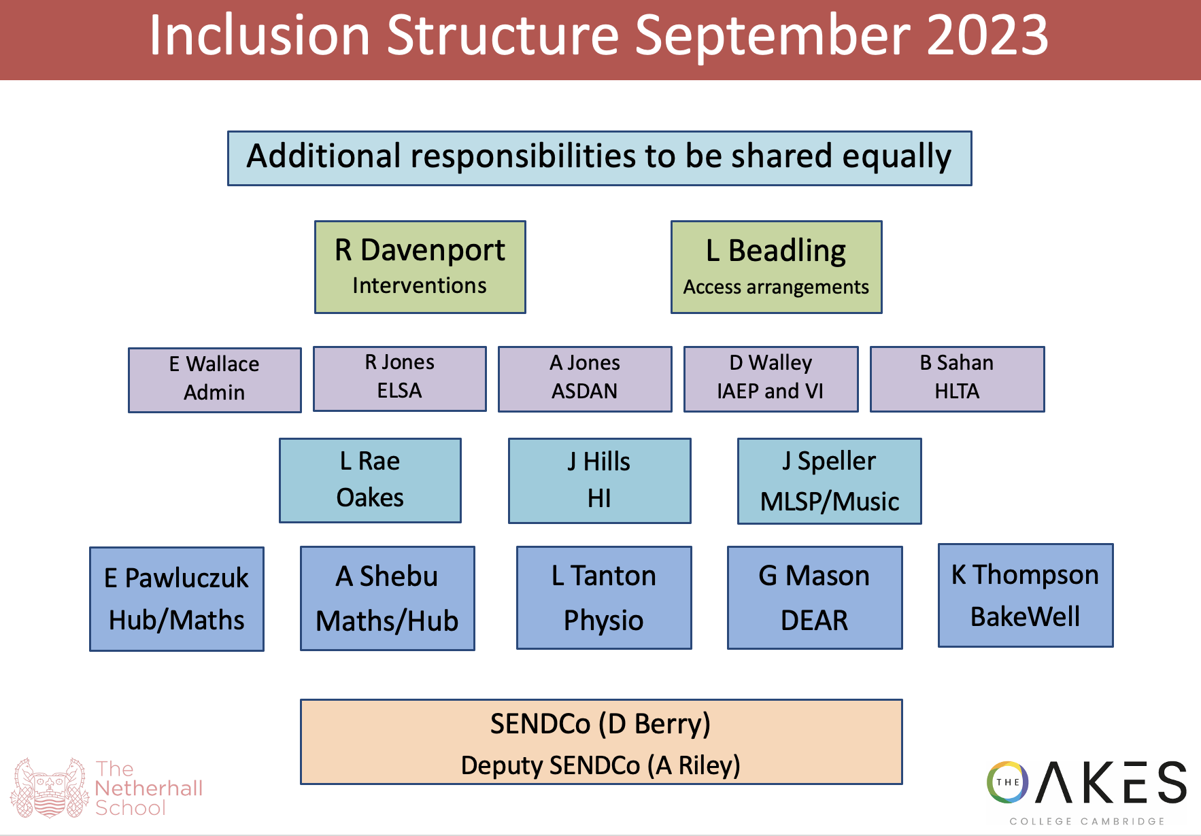

What kinds of special educational needs and disabilities might students at Netherhall have?
There are four broad areas of SEND:
- Communication and interaction (C&I)
  - Speech, Language & Communication needs (SLCN)
  - Autism Spectrum Disorder (ASD)
- Cognition and learning (C&L)
  - Profound and Multiple Learning Difficulties (PMLD)
  - Severe Learning Difficulties (SLD)
  - Moderate Learning Difficulties (MLD)
  - Specific Learning Difficulties (SpLD)
- Social, emotional and mental health (SEMH)
- Sensory and/or physical (P&S)
  - Hearing Impairment (HI)
  - Visual Impairment (VI)
  - Multi-sensory Impairment (MSI)
  - Physical Disability (PD)

The following descriptions are taken from the SEN code of practice (2014: 97-98)

Communication and interaction
Young people with speech, language and communication needs (SLCN) have difficulty in communicating with others. This may be because they have difficulty saying what they want to, understanding what is being said to them or they do not understand or use social rules of communication. The profile for every child with SLCN is different and their needs may change over time. They may have difficulty with one, some or all of the different aspects of speech, language or social communication at different times of their lives.
Children and young people with an Autism Spectrum Disorder (ASD), including Asperger’s Syndrome and Autism, are likely to have particular difficulties with social interaction. They may also experience difficulties with language, communication, social interaction and imagination, which can impact on how they relate to others.

Cognition and learning
Support for learning difficulties may be required when children and young people learn at a slower pace than their peers, even with appropriate differentiation. Learning difficulties cover a wide range of needs, including moderate learning difficulties (MLD), severe learning difficulties (SLD), where children are likely to need support in all areas of the curriculum and associated difficulties with mobility and communication, through to profound and multiple learning difficulties (PMLD), where children are likely to have severe and complex learning difficulties as well as a physical disability or sensory impairment.
Specific learning difficulties (SpLD), affect one or more specific aspects of learning. This encompasses a range of conditions such as dyslexia, dyscalculia and dyspraxia.

Social, emotional and mental health difficulties
Children and young people may experience a wide range of social and emotional difficulties which manifest themselves in many ways. These may include becoming withdrawn or isolated, as well as displaying challenging, disruptive or disturbing behaviour. These behaviours may reflect underlying mental health difficulties such as anxiety or depression, self-harming, eating disorders or physical symptoms that are medically unexplained. Other children and young people may have disorders such as attention deficit disorder, attention deficit hyperactive disorder or attachment disorder.

Sensory and/or physical needs
Some children and young people require special educational provision because they have a disability which prevents or hinders them from making use of the educational facilities generally provided. These difficulties can be age related and may fluctuate over time. Many children and young people with vision impairment (VI), hearing impairment (HI) or a multi-sensory impairment (MSI) will require specialist support and/or equipment to access their learning. Children and young people with an MSI have a combination of vision and hearing difficulties, which makes it even more difficult for them to access the curriculum or study programme than for those with a single sensory impairment.
Some children and young people with a physical disability (PD) require additional ongoing support and equipment to access all the opportunities available to their peers.

How are students with SEND identified?

In the first instance students and their parents/ carers should speak to the form teacher/ mentor or subject teacher if they have a concern. The primary support for all students is delivered through quality first teaching and in-class support from the subject teacher or tutor. The teacher or parent may refer to the SENCO if there are still concerns after this first wave of support and intervention.

Early identification is a priority, and we use screening and assessment tools to establish children’s progress through:
- teacher observation or assessment,
- Children’s acadmic and pastoral performance,
- Standardised screening or assessment tools e.g. diagnostic tests, reports or observations, records from previous schools.
- Discussions with primary schools and year 6 teachers.

Your child will only be placed onto the SEND Support Register if we are completing an active, measurable piece of work with them. They will be classed as having SEN Support if this is the case. This piece of work could be carried out over half a term for example and then, if successful, your child would be removed from the SEND support register. You will of course be aware of this as you will receive an assess, plan, do and review plan.

A diagnosis of Dyslexia, ADHD and or Autism et al., for example, will not automatically mean that your child will be placed onto the register. If specific work is not required then reasonable adjustments will of course be implemented within the mainstream classroom.

Procedures for identifying students with SEND include extensive liaison with primary or other transfer schools, literacy assessments including reading and spelling ages, MidYIS testing, collaboration between teachers and the Inclusion Faculty and additional assessments, including access arrangements for exams, which are carried out by the Inclusion faculty on a needs basis.

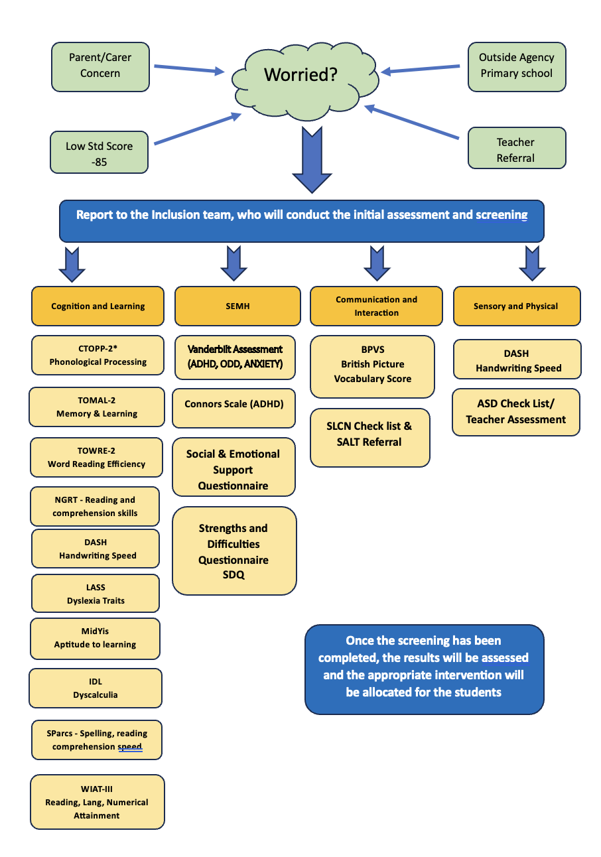
What provision is available for students with SEND at Netherhall?
The primary support for all students is delivered through quality first teaching and in-class support from the subject teacher or tutor.
The School’s approach to supporting students learning needs is underpinned by the Anglian Learning Trust’s approach and is summarised below.
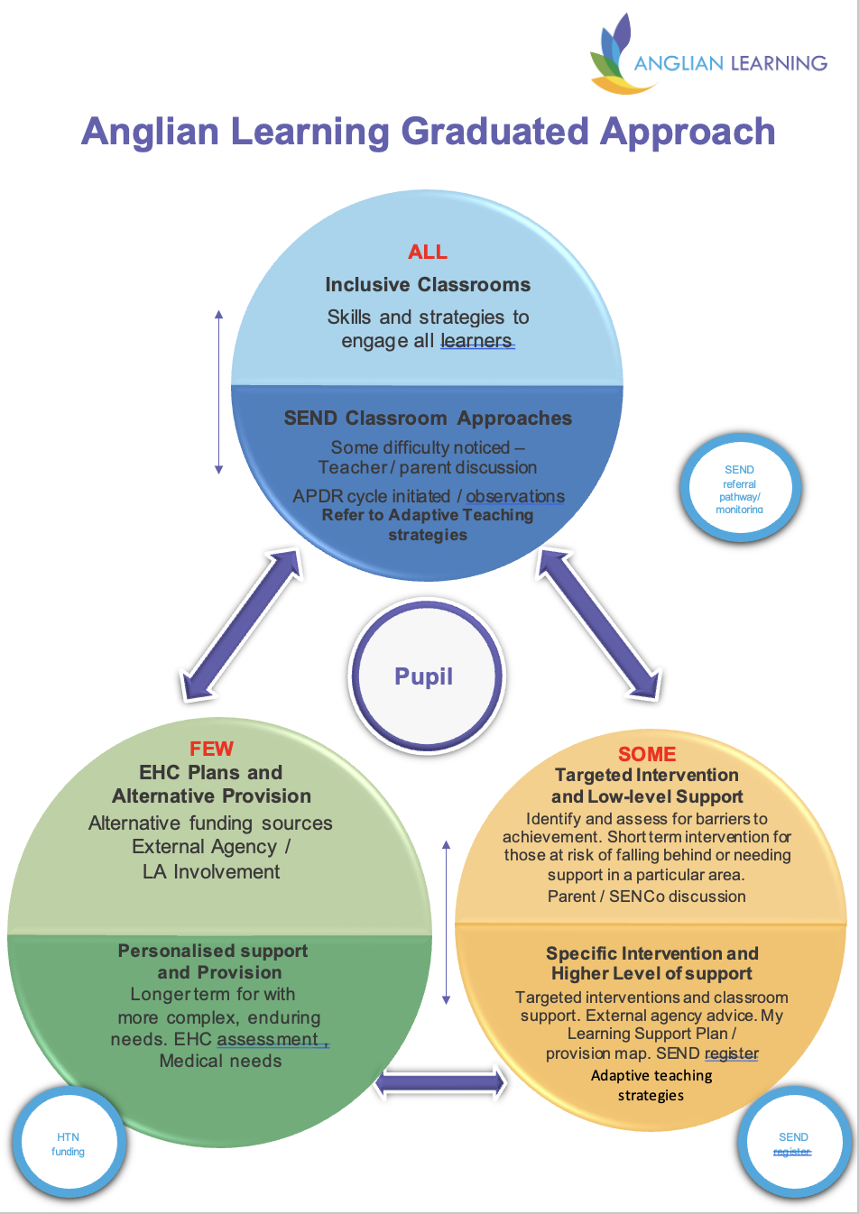

Area of need | Provision
General | • High quality teaching, differentiated for individual pupils, is the first step in responding to pupils who have or may have SEND.  • The Netherhall Data System allows all staff to access information related to the special educational needs and disabilities of individual students. This includes student profiles, EHCPs and information on students with SEND  • Teaching assistants work alongside teachers to provide additional support in some lessons and during intervention sessions  • Break and lunch time provision includes supervised rooms for smaller groups of students to eat and interact  • Comprehensive bespoke provision provided for students through in-school provision in the Hub.  • The Intervention Team meet and assess students to learn more about their needs, working with them to develop strategies that can be implemented by teaching staff and the students themselves to support their individual learning needs.  • Access arrangements such as extra time or a reader to those that qualify. These are overseen by the Intervention Team in conjunction with the Exams Office to ensure that these students feel safe, secure and supported during their examinations.
Communication and Interaction | • Targeted programs to improve communication and interaction skills, usually in small groups or individually working with a Teaching Assistant.  Support programmes delivered by our ELKLAN trained specialists include: Sound Training, WordShark, Direct Phonics and PiXL code. Referral to SLCN team.
Cognition and Learning | • Small group and individual programs for students with literacy and numeracy difficulties  • Study Support lessons to allow pre-learning and over-learning of concepts.  Support programmes include: NumberShark, WordShark, Lexia, Lexoniks.
Social, Emotional and mental health needs | • Targeted programs to support social and emotional development including access to the Hub if/when an adapted timetable is appropriate. Specific interventions include Art therapy, K9 confidence and 121 ELSA support sessions.  • Extensive pastoral support, including form tutors and mentors, school achievement leaders, pastoral support workers and SLT link staff who provide emotional support for students who need it, who may refer to specialist mental health support, including counselling, through the Locality and Child and Adolescent Mental Health (CAMH) teams, Key workers in school, mentoring (where appropriate) `and providing a quite ‘safe’ space for children to find peace at social times during the school day.  We use the Zones of Regulation strategy across the school and particularly in the Inclusion department.
Sensory and Physical needs | • Close liaison with multi-disciplinary teams, including physiotherapy, occupational therapy and hearing and visual impairment specialist services  • Individual and small group programs  • Adaptation of teaching resources where needed, including the use of ICT and accessible equipment
All students who are on the SEND register have a learning support plan, that is written in conjunction with the students and reviewed at least annually with the students input and feedback.
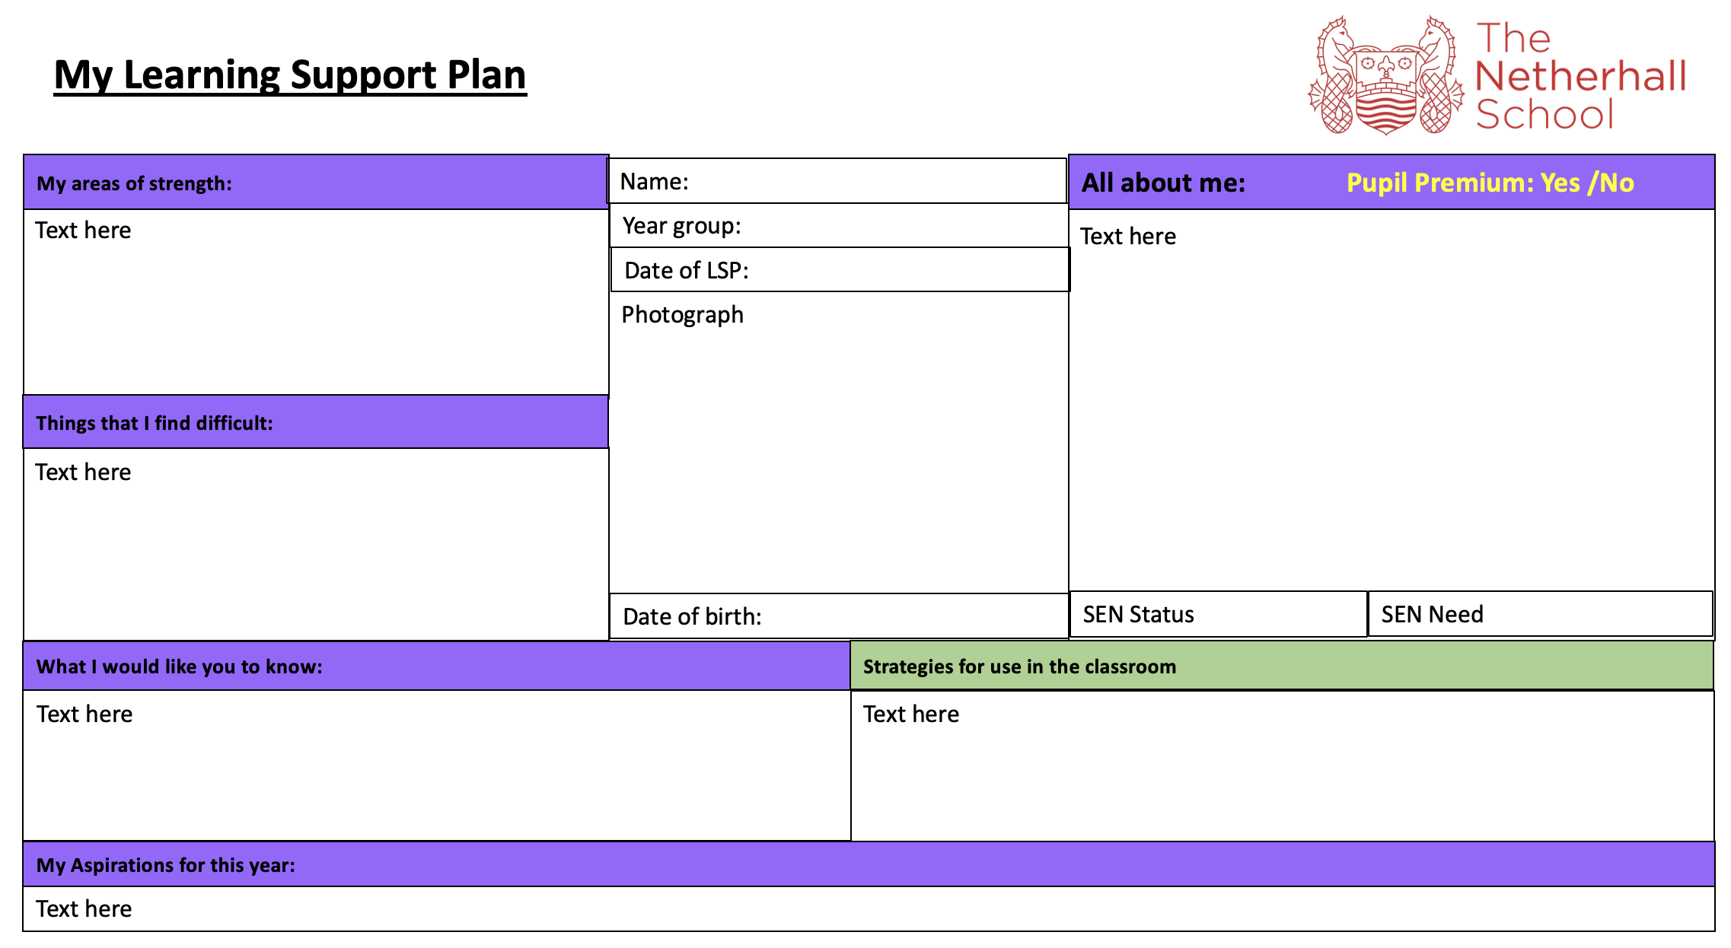

How is progress reviewed and shared with students and their parents and carers?
We aim to build strong and meaningful relationships with all stakeholders at Netherhall School. We will always seek to communicate effectively and regularly with our students by:-
- Communication as needed via phone calls, emails and through the student planners
- Parents evenings and additional SEND focus-parents evenings
- Informal ‘coffee afternoon’ at the start of the year to support transition into the new school year
- Confirmation of exam access arrangements is via letter
- Annual Reviews for students with Education, Health & Care Plans
- Through the Netherhall Data System and Provision Mapping software
- Information in the whole school weekly newsletter
- Annual parent surveys

However, we always welcome feedback from parents and carers, so we encourage all stakeholders to contact us using the contact details shown below.

Selected responses from the parent survey July 2023
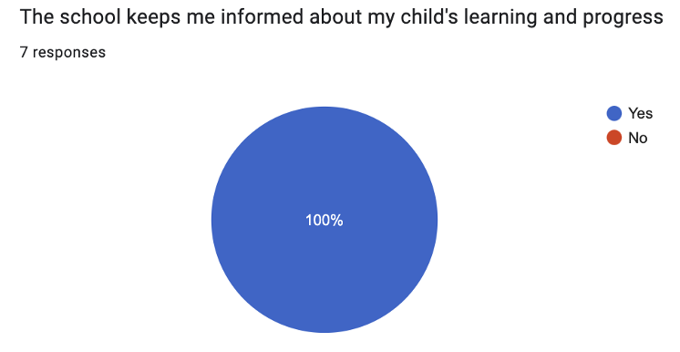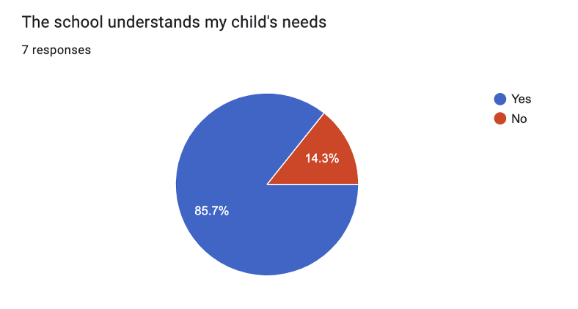
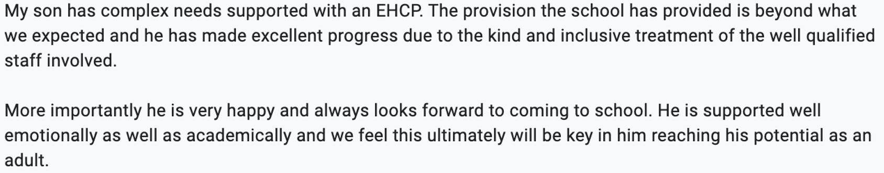

What training or expertise do staff have?
In a rapidly evolving education system, it is important to ensure that our staff are always updated and skilled to support our students to the best of their ability. We offer a comprehensive training program to all staff around the specific designations for SEND students, described above. We also have, in house experts who specialise in supporting students with key SEND needs.
All staff get access to the SEND handbook which provides information about the support, policy and practice for supporting SEND students at Netherhall School. This document includes a comprehensive strategy section for supporting students with SEND.
Specific information is shared with staff through our NIMBUS and Edukey software packages and the learning support plans.

Key staff have specialist training in a range of SEND areas, including Speech and Language, Social, Emotional & Mental Health, Dyslexia, Autism and Hearing Impairments and the SENCO/Assistant SENCO attends county networking, Anglian Learning Trust meetings and other SEND forums as appropriate.

We offer a comprehensive support an training program across the year for all out staff. This included (but is not limited to) the following areas in the 2022-23 academic year:-
- Attachment and Trauma awareness
- Supporting students with Autism
- Step-on Training (Therapeutic model for behaviour management)
- Adverse Childhood Experiences
- Zones of regulation training
- Epilepsy awareness for schools and teachers
- Safeguarding and PREVENT training
- EVAC chair (fire evacuation) training
- Pathological demand avoidance (Local authority led)
- ADHD and Autism training (Local authority led)

In the academic year 2023-24 we will continue to offer drop-in sessions to all staff on a Tuesday afternoon and fortnightly whole staff briefings on a Monday morning. These sessions will focus on the practical support and adjustments that can be made to lessons to ensure engagement and progress of all SEND students at Netherhall School.

How will the school know that its provision for SEND is effective?
Progress of students is regularly assessed and reviewed in order to determine the effectiveness of any additional intervention programs through the use of pre- and post-tests related to the intervention.
Teaching staff are expected to assess all students at regular intervals across the school year and at specific points in the school calendar. These data can be updated ‘live’ throughout each term. The data system allows tracking of data and interventions.
We use the APDR (Assess, Plan, Do and Review) model for supporting all students with SEND at Netherhall School.

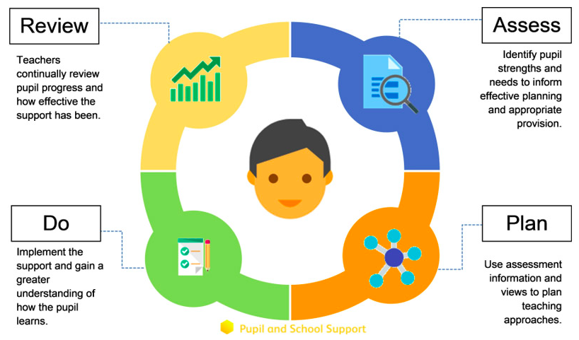
https://schools.local-offer.org/send-toolkit/send/assess-plan-do-review/assess-plan-do-review-overview/

The Inclusion Faculty also regularly self-evaluates its provision through weekly meetings, liaison with external agencies and discussions with focus groups of students. Feedback is regularly collated for annual reviews of students with EHCPs regarding both the progress of students and the impact of TAs on their learning. Observations of TAs are carried out to reflect on their effectiveness in supporting students.

Students are encouraged to feedback on their progress (academic and pastoral) when they review their learning support plans. However, we always welcome feedback from parents and carers, so we encourage all stakeholders to contact us using the contact details shown below.

Selected Results from our 2023-2023 interventions
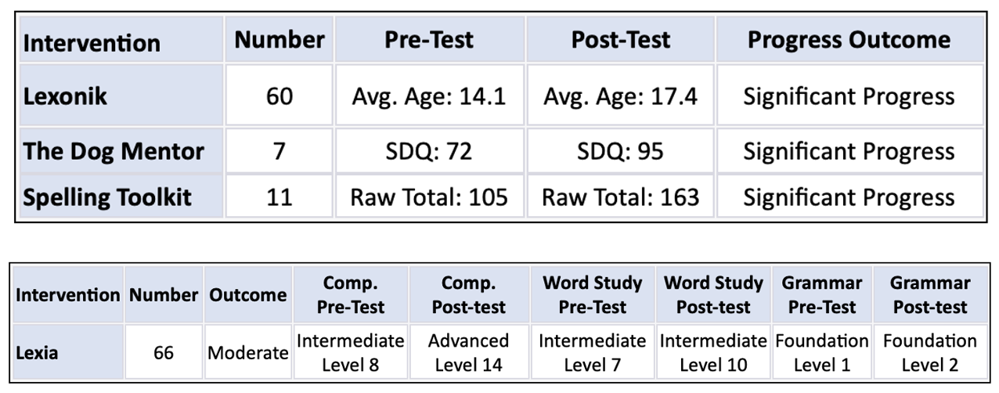

Selected Parent Survey data from July 2023
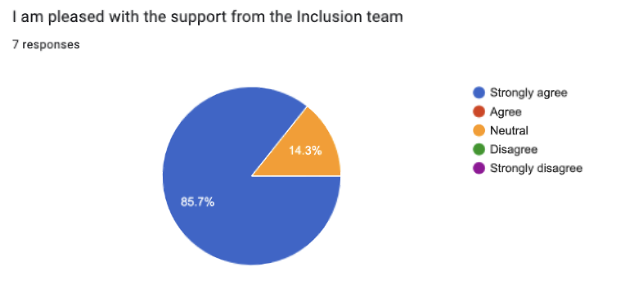
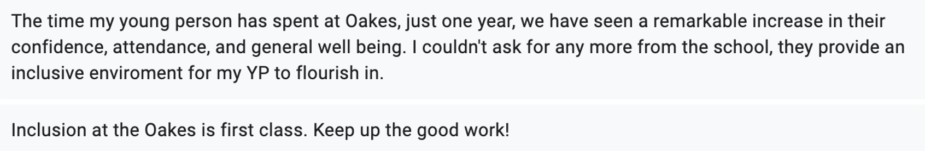
Selected Student Survey data from July 2023
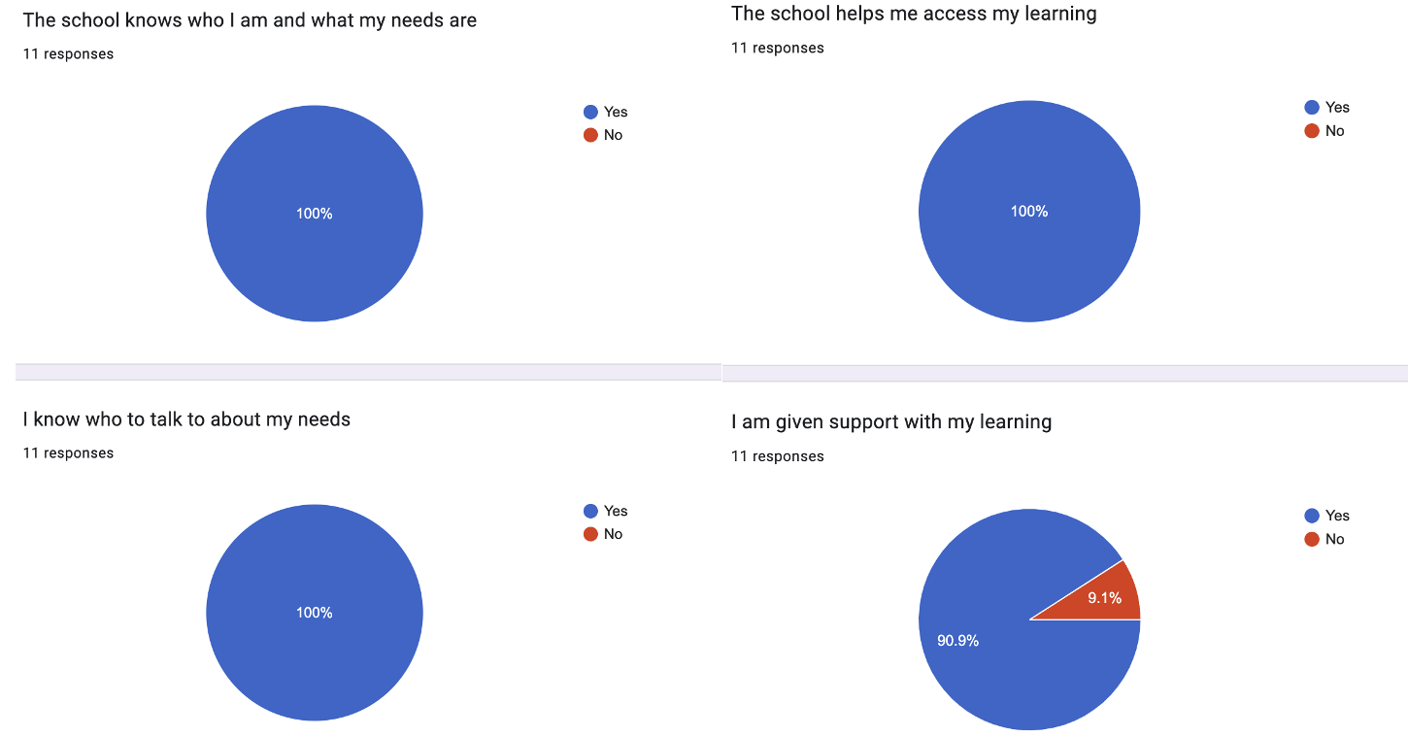

How do we incorporate the views of our students in decision making?
For Children with EHCplans, during the year 6 transition interview you and your child will be invited to attend an interview with a member of Netherhall’s staff so that you can share your successes and discuss any concerns you may have.

Children on the SEND register create their one-page learning support plan with their keyworker and parent/carer so that they contribute to the way they would like their support to be provided.

They also have a formal yearly meeting called an Annual Review. At Netherhall, all children are invited to attend. They also complete a document called ‘Moving Forward’ which covers their likes, dislikes, areas of success and areas for development along with their concerns, ideas and thoughts about their future education and career ideas.

Children with EHC plans have an allocated keyworker who they speak with on a very regular basis. Keyworkers help them create their ‘One Page Profiles’ and ensure that they are able to contribute, in the most suitable way for them, in their Annual Review.

If your child is invited to intervention sessions, you will receive a communication (usually email explaining why, when and where the interventions are. You can, of course, speak with us if you have questions or indeed want to provide extra support for your child at home.

The SENDCo carries out termly and annual SEND Student Voice activities. This is where he carries out informal interviews with a range of SEND children asking about their provision, what is working well and if she can help with improving things in any particular areas. These interviews are anonymous to enable children to feel comfortable with sharing any concerns they may have.

You can of course speak with teaching staff at your child’s parent/carer evening as well as email them. If you need to speak with people in person, then you can arrange to meet with your child’s form tutor or Head of House in the first instance.

Any child placed onto the SEND Support Register will be carrying out some form of measured intervention. The Code of Practice states that SEN Support should, “take the form of a four-part cycle through which earlier decisions and actions are revisited, refined and revised with a growing understanding of the pupil’s needs and of what supports the pupil in making good progress and securing good outcomes. This is known as the graduated approach.”
This is the ADPR cycle described above. Carrying out an intervention fulfils the ’Do’ section and then following the completion of that timed piece of work we ’Review’ the cycle. Again, both children and parents are involved in the ‘Review’ process.

Selected Student Survey Results July 2023
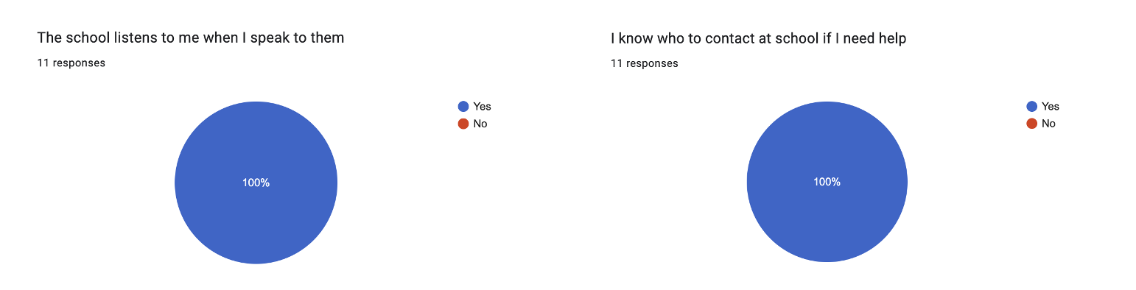

Who is involved in supporting students with SEND?
The primary point of contact for all students and parents is through the form tutors / mentors and subject teachers, in liaison with year leaders and heads of faculty.
The first wave of support for all students is delivered through quality first teaching and in-class support from the subject teacher or tutor.

The Special educational needs coordinator (SENCO) is responsible for overseeing the provision for SEND. The SENCO works closely alongside the team who are responsible for the operational delivery of SEN provision across the school, the Deputy Principal and other members of the Inclusion team (see infographic above).

Deputy Principal –  SENDCO | Daniel Berry | dberry@netherhallschool.org | 01223 868314
Deputy SENDCo | Anjuli Riley | ariley@netherhallschool.org | 01223 868332

What specialist services are available?
The school liaises extensively with other bodies, including health and social services, local authority support services and voluntary organisations, in order to seek specialist advice and provision.

We are happy to work with outside agencies in supporting our children. A weekly inclusion meeting is held to discuss students who are experiencing difficulties and when appropriate a referral to one or more services may be made to:
- An Educational Psychologist
- Child and Adolescent Mental Health Services (CAMH)
- Physiotherapist and Occupational Therapists
- Sensory Support services
- Family Workers
- Young People’s Workers
- Children’s Services
- School nurse
- Education Welfare Officer (EWO)
- School counsellor
- Kite Trust
- Embrace
- Casus

Some of these services require an Early Help Assessment (EHA) to be carried out. This is how parent/carers, the child and a practitioner or worker assess the need and access support. Parent/carers are very much at the heart of an EHA referral.
If an EHA is successful, usually a Team Around the Family (TAF) will be called. This is where the most appropriate worker calls a meeting, sets targets, inputs support and then reviews the effectiveness of that support. This can form an essential part of the ADPR cycle.

The link to the MASH and EHA gateway can be found here
The Link to the Cambridgeshire local offer can be found here

How are students supported in moving between different schools?
Transition for all students from primary schools include the following:
- Staff information- sharing meetings and primary class activities,
- Visits to primary schools to see the support already in place,
- SENCO liaison meetings,
- Ongoing liaison work between subject departments and primary schools,
- Parents evenings
- Student induction days.

The Inclusion faculty has allocated Higher Level Teaching Assistants to work with specific feeder primary schools around transition for SEND students.
For some students, there are extra transition opportunities, including: individual parental and student visits, additional taster sessions, liaison and observations with teaching assistants, summer school
Transition for students moving to post-16 providers include individual visits and taster days, liaison meetings between SENCO, pastoral team and post-16 providers.

If your child is starting at Netherhall in year 7 or in year 12 as part of the typical primary school to secondary school transition or CAP application process. The SEND team will liaise with the primary school to ensure that the appropriate information is shared with us.
Children with EHC plans will be offered an opportunity to visit the school prior to the summer term transition days to allow for further support and preparation.
The Netherhall School offers an additional primary transition morning, prior to the city-wide transition day specifically to support students with SEND.

How do we ensure that students have access to all opportunities at Netherhall School?
All children, regardless of disability are included at Netherhall School.
For children with vision impairment we adapt the environment as is necessary. We have, for example, painted yellow lines on steps, ensured that posts and pillars have high contrast tape or paint around them and sourced highly contrasted sports equipment. Enlarged papers, fonts and coloured papers are also some of the ways we enable students to remain engaged with the main school system.
For students with physical needs adaptive equipment is available. This includes general stationery as well as equipment in technology and science for example. We also make use of assistive technology (ICT resources) within school.
We work hard to ensure all aspects of school life are accessible to student, if you wish to discuss any aspect of this please do contact us using the contact information above.
You can read our access policy statement here

The Hub
The purpose of The Hub is to support students to be able to access a mainstream lesson. In doing this, The Hub mainly supports students with mental health challenges, emotional based school avoidance and medical needs.
Students can attend part or full time. Referral to the Hub is made via the Inclusion meeting and or the ‘Every Child Matters’ meetings that occur weekly in school. Emergencies are managed on an individual basis.
Referrals to the Hub are designed to be short term, with a view to supporting students back to mainstream full-time learning. Any placement in the hub is reviewed at least half-termly and we actively encourage parent/carer attend these review meetings.
The Hub also accommodates students with medical needs and often acts as a bridge between home, hospital and school.
Students in ‘crisis’ can be accommodated in The Hub as a result of pastoral requests only.

Break and lunchtime support is offered to all Hub and SEND students who cannot, as yet, manage the turbulence and complexity of secondary social times. Staff are timetabled to support these sessions.

The hub offers:
- Zones of Regulation, a cognitive behavioural approach to encourage students to manage their feelings,
- Small group primarily focusses on preventing students from falling behind in their academic studies but also,
- Small group work takes place which focusses on closing developmental and academic gaps,
- Creative, therapeutic activities aimed at improving self-awareness,
- Work focussed on developing resilience and self-efficacy.

How are students supported in preparing for adulthood and independent living?
We firmly believe that it is our role to prepare our students for the working world, to ensure they have the appropriate skills and to help them make appropriate, informed decisions for each step of their career.

All staff at Netherhall play a role in providing guidance to students, in their capacity as form tutor, subject teacher, Head of House (School Achievement leader) or Senior Leader. All subject areas and extra-curricular activities help to prepare students in some way for the working world, whether that is through developing communication skills, team-work or problem-solving activities, or meeting local employers (both in school and on visits).

All students with a SEND designation have work-related learning programs and work experience opportunities, that are developed with their specific needs in mind.
Some students with SEND have additional targeted work experience, which can include weekly placements in a variety of settings.
All students with SEND are prioritised for early interviews with our independent careers advisor and we ensure that the local authority Senior Transition Advisor meet with all students with EHCplans at least once in year 11.

Our CEIAG programme has been developed in consideration of the Gatsby Report’s benchmarks, and the CDI (Career Development Institute) Framework for careers, employability and enterprise education 7-19.

For further information please see our website (here) or contact our Lead for Careers – Mr Dan Carlson (dcarlson@netherhallschool.org – 01223 242931)

What are the procedures for making a complaint?
Please contact the SENCO, or follow the whole school complaints policy as detailed on the school website (here).

Other useful sites/contact numbers for parent/carers may include:
SENDIAS 01223 699 214
Offers impartial and confidential information, advice and support to parents and carers who have a child or young person with special educational needs (SEN) or a disability).

Keep Your Head https://www.keep-your-head.com
(Reliable information on mental health and wellbeing for children, young people
and adults across Cambridgeshire & Peterborough).
Emotional Health and Wellbeing Service
https://www.keep-your-head.com/prof/cp-mhs/supporting-young-people-in-crisis/emotional-health-1
Emotional Health and Wellbeing Service for Children and Young People provides therapeutic support in a variety of ways.

Kooth https://kooth.com
Kooth is an online counselling and emotional well-being platform for children and young people, accessible through mobile, tablet and desktop and free at the point of use.

Chat Health https://chathealth.nhs.uk/
Chat health is a Confidential help and advice service delivered through text message and mobile devices. As the website says…
It’s safe and easy for you to speak to a qualified health professional. Just send a message, you don’t have to give your name.
Discreet and quick. It only takes one message to start making a difference. You’ll get confidential advice from trained health staff in your area.

Carers Trust = https://www.carerstrustcpn.org
The Carers Trust Network supports carers locally through a unique UK-wide

Updated: 01.09.23

